 | KIDS ART CHALLENGE *

DRAW YOUR FOOD ALLERGY HERO!
A food allergy hero helps you feel safe, brave and included.
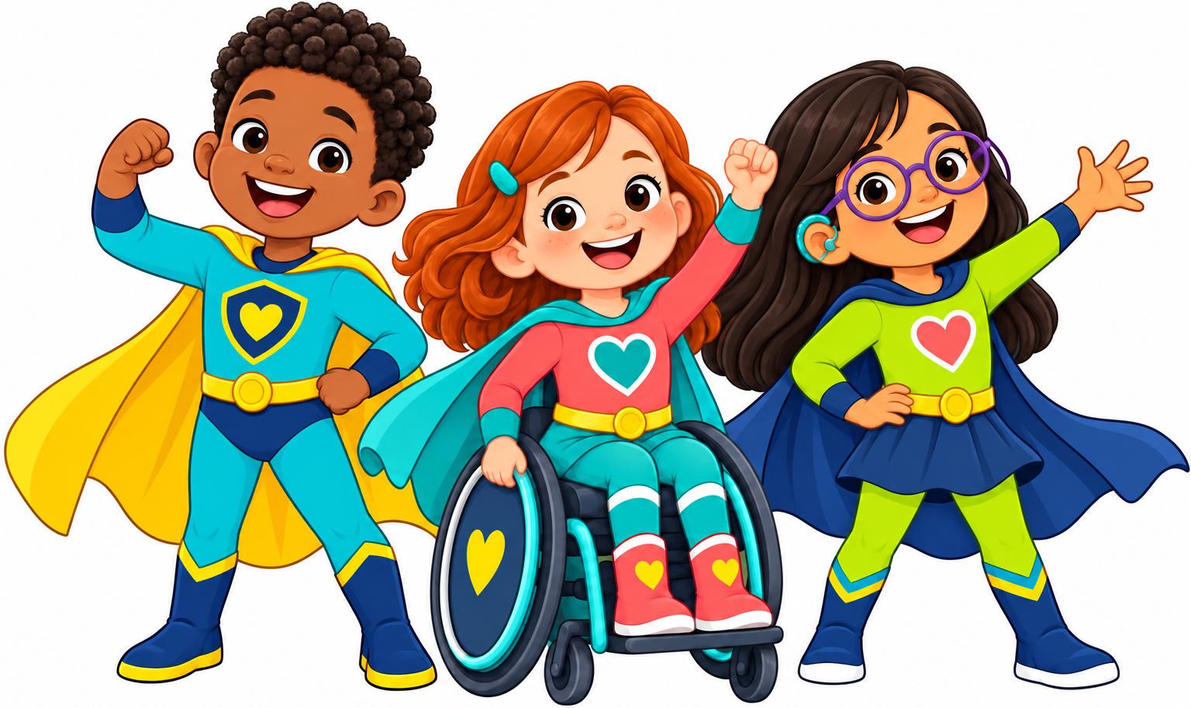
Your hero could be a parent, friend, teacher, doctor, nurse - or YOU!
DRAW YOUR HERO HERE
Use pencils, crayons or markers
My first name: __________________ Age: _____
My hero's name is: _______________________________
My hero is amazing because: _________________________
_______________________________________________________________________________
Need help? A grown-up can write your words for you.
HOW TO ENTER
Ask a parent or guardian to photograph or scan this page and email it to foodallergyheroesAMF@gmail.com by 8 October 2026.
In the email, include the child's first name and age, plus a parent or guardian's name and contact details.
PRIZE: The winner will receive a gift voucher and a special award, and will be announced at the Food Allergy Gala fundraiser on 21 October 2026. www.allergycharity.com/events
For safety, please do not write a surname, home address, school name or medical details on this page.

